**:: DBMS PROJECT ::**

**“DIGITAL MARKETING AGENCY MANAGEMENT SYSTEM”**



Computer Engineering Department

Birla Vishvakarma Mahavidyalaya

Vallabh Vidyanagar October – 2022

Guided By

Prof. Kirtikumar J. Sharma

Developed by

Navneetkumar R. Thakor 21CP031



( An Autonomous Institution )

Computer Engineering Department

Birla Vishvakarma Mahavidyalaya

**Certificate**

I, hereby, certify that this project report entitled “E-PM Portal” submitted to BVM, V.V. Nagar in partial fulfilment of requirement for the Degree of Diploma Engineering embodies the result of the Bonafied work carried out by:

|  |  |  |
| --- | --- | --- |
| Sr.no | ID no | Name |
| 1 | 21CP031 | Navneetkumar Thakor |

I find the work complete and sufficient high standard to warrant its presentation for the examination.

I further certify that the work has been carried out under my guidance.

Guided By:

Prof. Kirtikumar J. Sharma

Place: V.V. Nagar

Date:

**INDEX**

**1.Functional Requirements**

**2. System Design**

1. Entity Sets

2. Relationship Sets

3. Entity Relationship Diagram ( ERD )

4. Relational Model

5. Relational Table

6. Normalization

7. Relational Schema

**3 Schema In PostgreSQL**

1. Create Schema

2. Create Tables & Insert Records

3. Some queries with output to retrieve vital records from the database.

**Functional Requirements**

1. Agency point of view

* Agency can Enter and Mange & Delete all the details.
* Agency can Maintain & Mange the Client’s personal details.
* Agency can also Enter, Delete & Mange the information about different departments which exists in agency.
* Agency can Enter, Delete & Mange the record of staff in which, their personal information, their position in agency.
* Agency can also Mange the personal account for every client which consists many kinds of projects.
* Agency can Manage the record of all the projects which is going on or completed under dedicated department.
* Agency can also manage the salary for staff members along with bonuses which is given them for their special efforts in particular project, for particular month.

1. Non-functional Requirement

* Performance
* Capacity
* Availability
* Security

**System design**

|  |  |  |
| --- | --- | --- |
| **No.** | **Entity set** | **Attributes** |
| **1** | **Employee** | **SSN, name (fname, lname), position, join_date,**  **Email, mobile, address (city, state, pincode), age, gender, adhar_no.** |
| **2** | **Salary** | **Hand_salary, bon_pid, bon_month, bonus, tot_salary.** |
| **3** | **Department** | **Dept_id, dept_name, mng_ssn,** |
| **4** | **Projects** | **P_id, cost, revenue, roi, str_date,** |
| **5** | **Client_Acc** | **tot_proj, tot_cost, tot_revenue,** |
| **6** | **Client** | **cid, name (fname, lname), comp_name, join_date, mobile, Email, mng_ssn, address (city, state, pincode), age, gender, adhar_no.** |

1. **Entity sets**
2. **Relationship Sets**

|  |  |  |
| --- | --- | --- |
| **Associations** | **Relationship name** | **Mapping Cardinality** |
| **Employee & Salary** | **Emp_Sal** | **One to One** |
| **Employee & Department** | **Emp_Dept** | **Many to One** |
| **Employee & Projects** | **Emp_Proj** | **Many to Many** |
| **Department & Project** | **Dept_proj** | **One to Many** |
| **Project & Client_Acc** | **Client’s Proj** | **Many to One** |
| **Client & Client_Acc** | **Client’s Acc** | **One to one** |
| **Client & Employee** | **Client’s Mng** | **Many to One** |

**3)E-R Diagram**

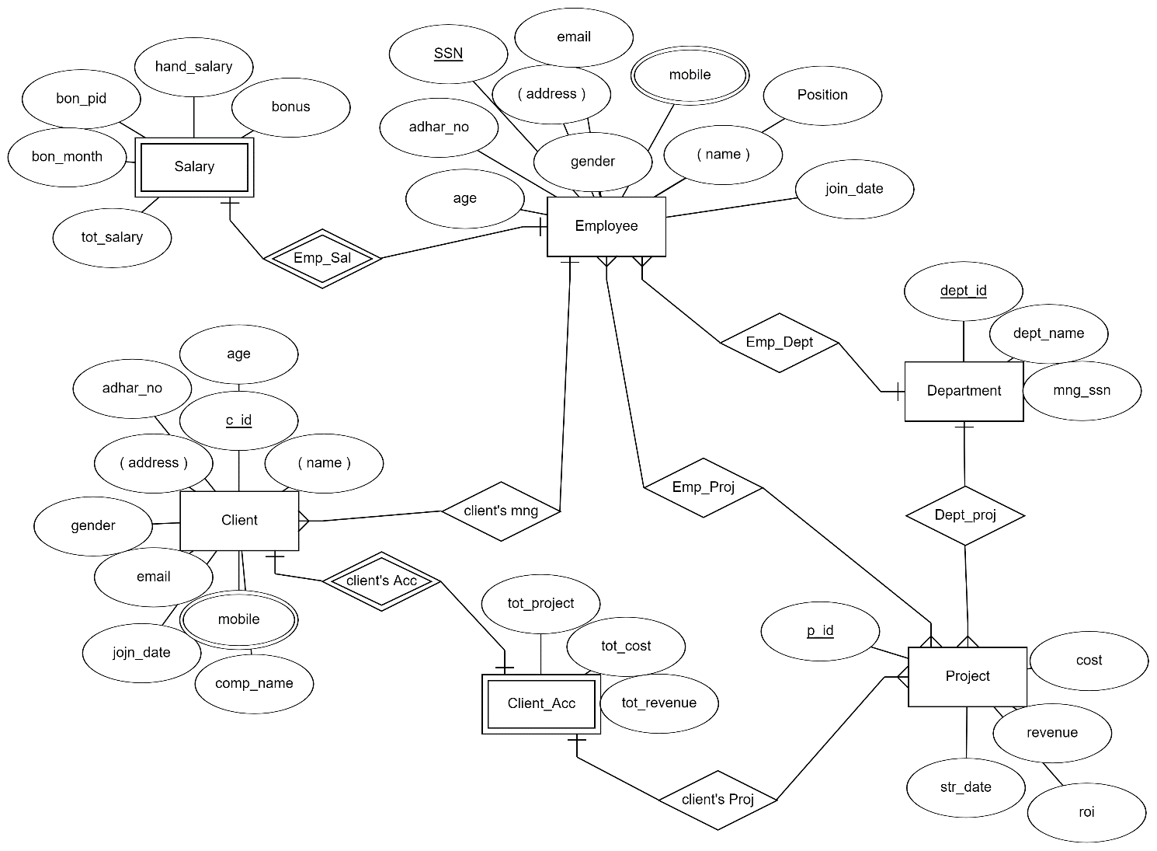

**4) Relational Model**

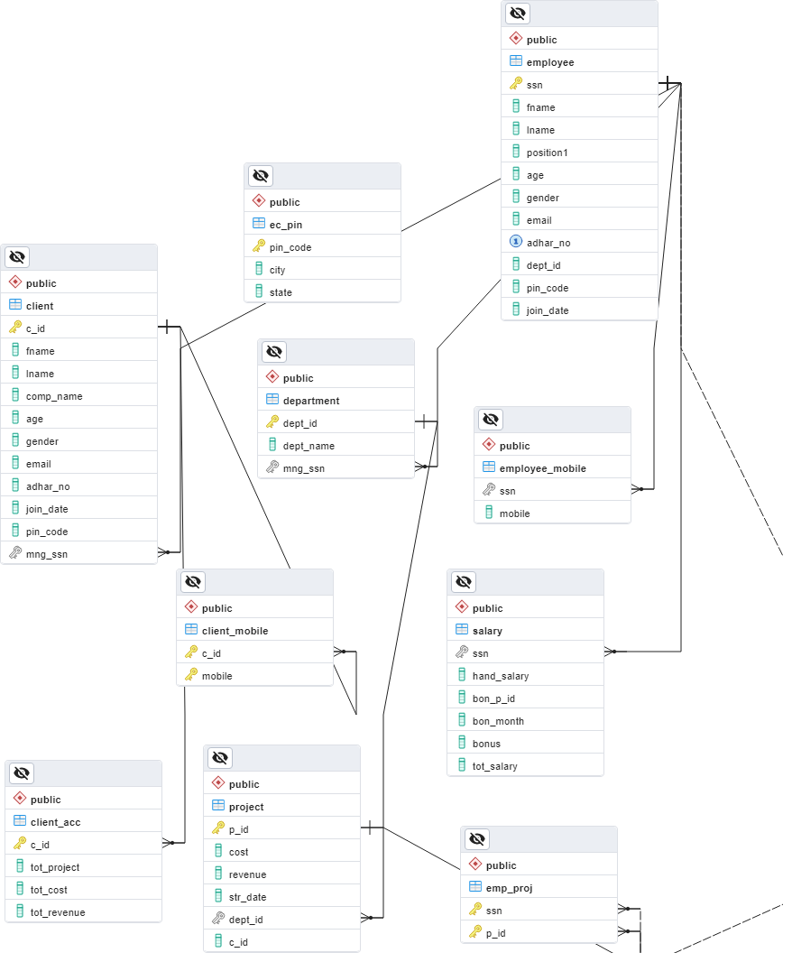

**5) Relational Tables**

|  |  |  |
| --- | --- | --- |
| No. | Entity Sets | Attributes |
| **1** | **Employee** | Ssn**,** fname, lname, position, age, gender, email, adhar_no, dept_id (FK), pin_code (FK), join_date |
| **2** | **Employee_mobile** | Ssn (FK), mobile |
| **3** | **Salary** | Ssn (FK), hand_salary, bon_p_id, bon_month, bonus, tot_salary |
| **4** | **Client** | C_id**,** fname, lname, comp_name, age, gender, email, adhar_no, join_date, pin_code (FK), mng_ssn |
| **5** | **Client_mobile** | C_id (FK), mobile |
| **6** | **Client_Acc** | C_id (FK), tot_project, tot_cost, tot_revenue, |
| **7** | **project** | P_id, cost, revenue, roi, str_date, dept_id (FK), c_id (FK) |
| **8** | **Department** | Dept_id, dept_name, mng_ssn |
| **9** | **Emp_proj** | Ssn (FK), p_id |
| **10** | **EC_pin** | Pin_code, city, state |

**6) Normalization**

1. Employee (ssn, fname, lname, position, age, gender, email, adhar_no, dept_id, pin_code, join_date**)** 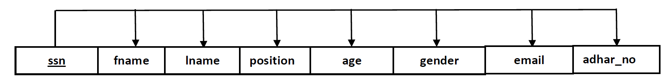

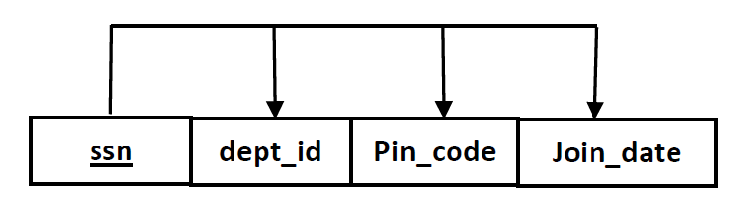

• The candidate key is SSN.

o FD1: {SSN}+ → { fname , lname , position, age, gender, email, adhar_no, dept_id, pin_code, join_date }

¬ 1NF: Meets the definition of a relation.

¬ 2NF: No partial Key dependencies.

¬ 3NF: No transitive dependency.

¬ BCNF: It is in BCNF.

2**.** Employee_Mobile (ssn,mobile**)**

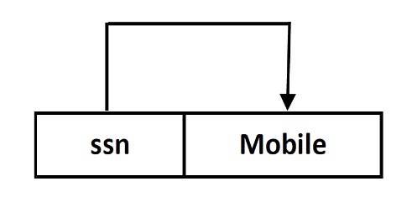

• The candidate key is { ssn, Mobile }.

o FD1: { ssn, Mobile }+ → { ssn, Mobile }

¬ 1NF: Meets the definition of a relation.

¬ 2NF: No partial Key dependencies.

¬ 3NF: No transitive dependency.

¬ BCNF: It is in BCNF.

3**.** Salary (ssn, hand_salary**, bon_p_id, bon_month, tot_salary)**

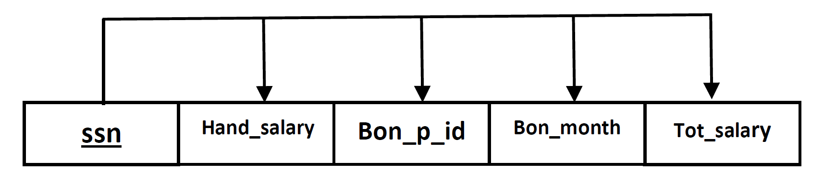

• The candidate key is ssn.

o FD1: { ssn }+ → { hand_salary, bon_p_id, bon_month, tot_salary }

¬ 1NF: Meets the definition of a relation.

¬ 2NF: No partial Key dependencies.

¬ 3NF: No transitive dependency.

¬ BCNF: It is in BCNF.

4**.** Client (c_id, fname, lname, comp_name, age, gender, email, adhar_no, mng_ssn, pin_code, join_date,**)**

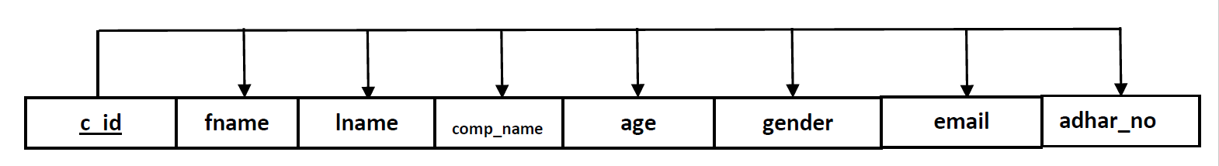

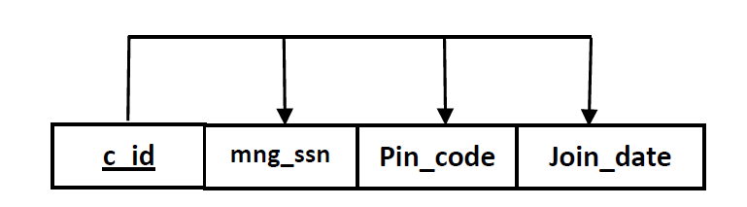

• The candidate key is c_id

o FD1: { c_id }+ → { fname, lname, comp_name, age, gender, email, adhar_no, mng_ssn, pin_code, join_date }

¬ 1NF: Meets the definition of a relation.

¬ 2NF: No partial Key dependencies.

¬ 3NF: No transitive dependency.

¬ BCNF: It is in BCNF.

5**. Client_Mobile ( c_id, mobile )**

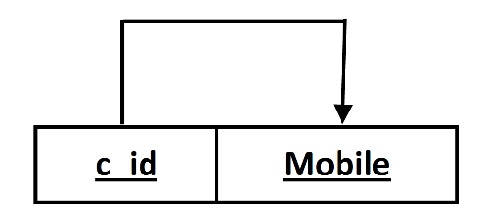

• The candidate key is { c_id, mobile }.

o FD1: { c_id, mobile }+ → {c_id , mobile}

¬ 1NF: Meets the definition of a relation.

¬ 2NF: No partial Key dependencies.

¬ 3NF: No transitive dependency.

¬ BCNF: It is in BCNF.

6**.** Client_Acc ( c_id, tot_project, tot_cost, tot_revenue **)**

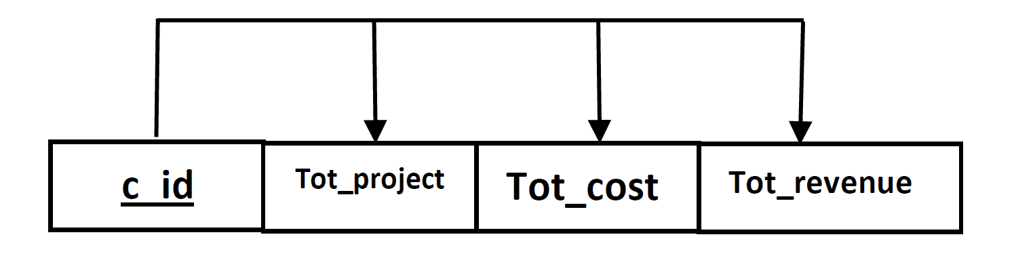

• The candidate key is c_id.

o FD1: { c_id }+ → { tot_project, tot_cost, tot_revenue}

¬ 1NF: Meets the definition of a relation.

¬ 2NF: No partial Key dependencies.

¬ 3NF: No transitive dependency.

¬ BCNF: It is in BCNF.

7**.** Project (P_id, p_name, cost, revenue, roi, str_date, dept_id**)**

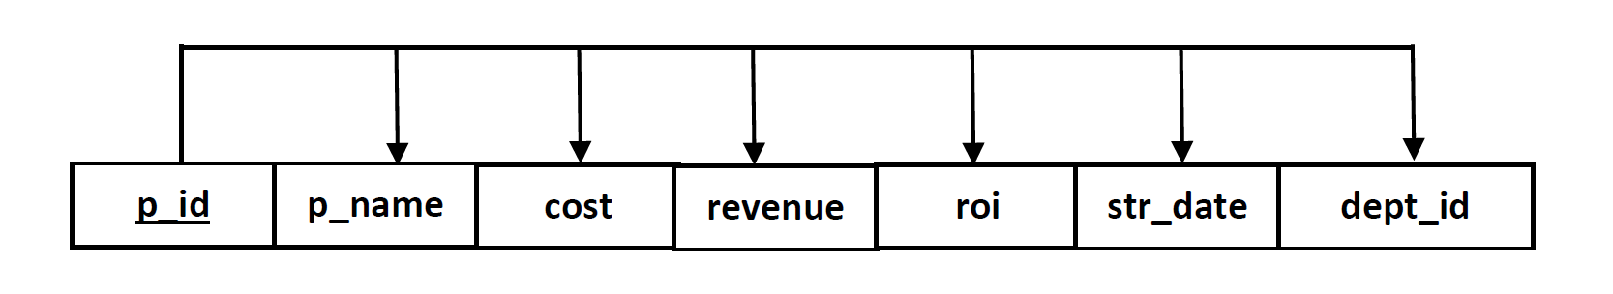

• The candidate key is p_id.

o FD1: { p_id }+ → {p_id, p_name, cost, revenue, roi, str_date, dept_id }

¬ 1NF: Meets the definition of a relation.

¬ 2NF: No partial Key dependencies.

¬ 3NF: No transitive dependency.

¬ BCNF: It is in BCNF.

8**.** Department (dept_id , dept_name, mng_ssn)

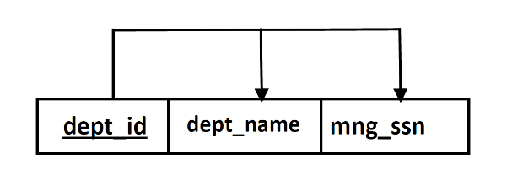

• The candidate key is dept_id.

o FD1: { dept_id }+ → { dept_id, dept_name, mng_ssn }

¬ 1NF: Meets the definition of a relation.

¬ 2NF: No partial Key dependencies.

¬ 3NF: No transitive dependency.

¬ BCNF: It is in BCNF.

9**.** Emp_proj (ssn, p_id)

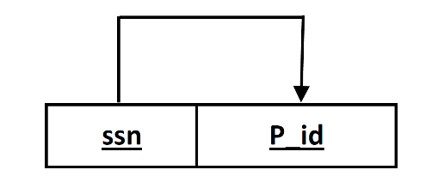

• The candidate key is ssn, p_id.

o FD1: { ssn, p_id }+ → { ssn, p_id }

¬ 1NF: Meets the definition of a relation.

¬ 2NF: No partial Key dependencies.

¬ 3NF: No transitive dependency.

¬ BCNF: It is in BCNF.

10**.** EC_pin (pin_code , city, state)

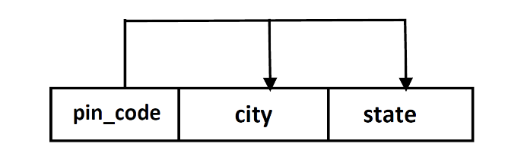

• The candidate key is pin_code.

o FD1: { pin_code }+ → { pin_code, city, state }

¬ 1NF: Meets the definition of a relation.

¬ 2NF: No partial Key dependencies.

¬ 3NF: No transitive dependency.

¬ BCNF: It is in BCNF.

**Create Schema**

**1) Employee**

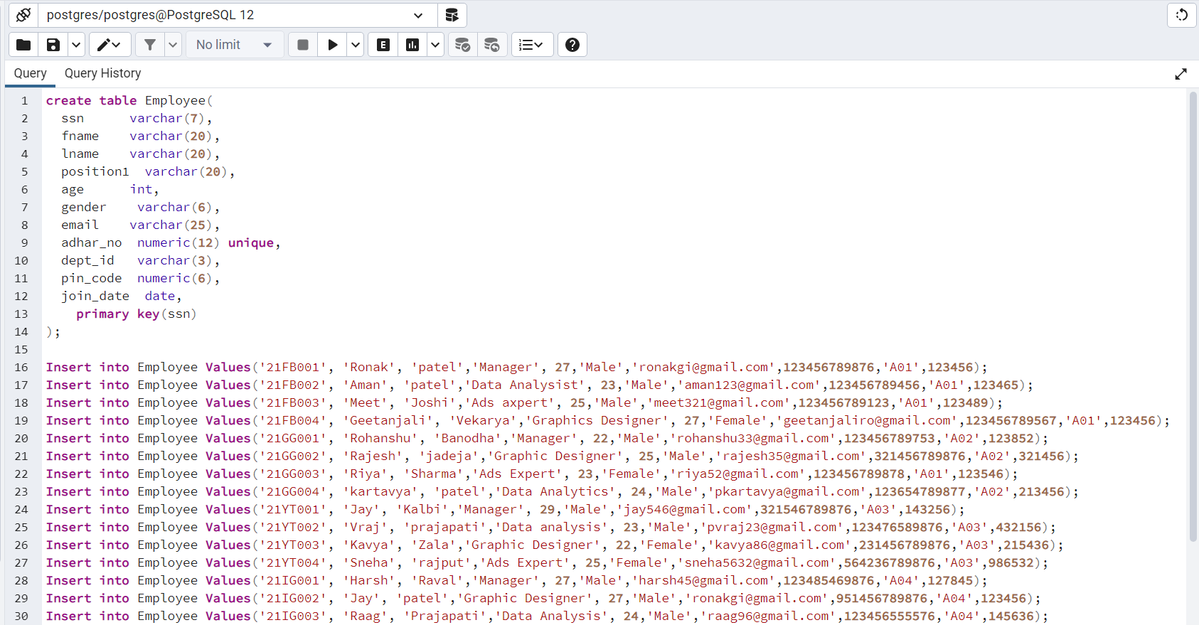

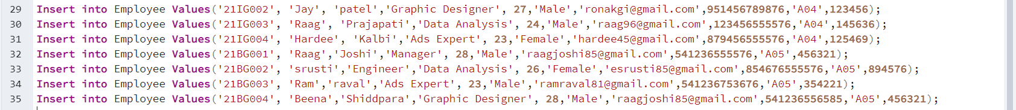

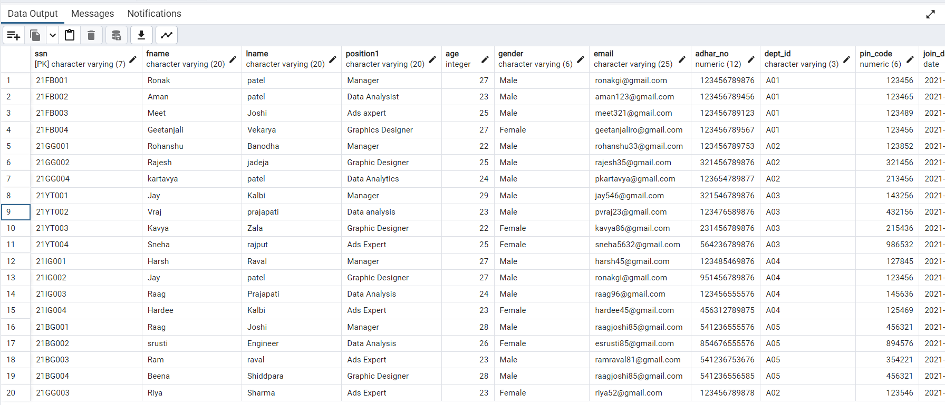

**2) Employee_Mobile**

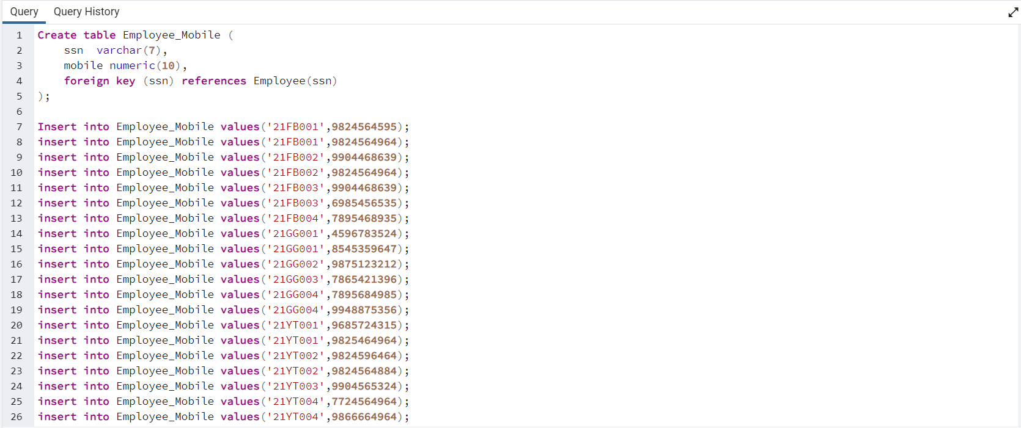

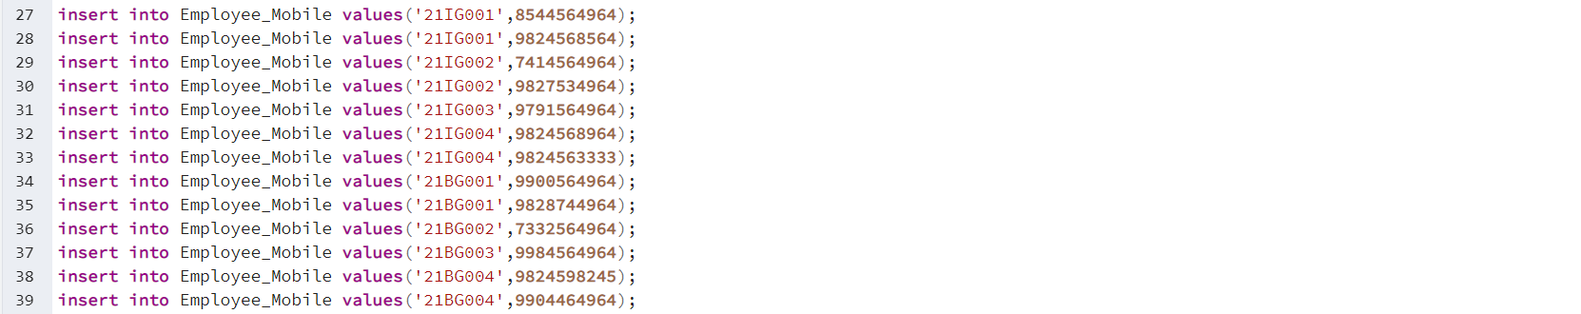

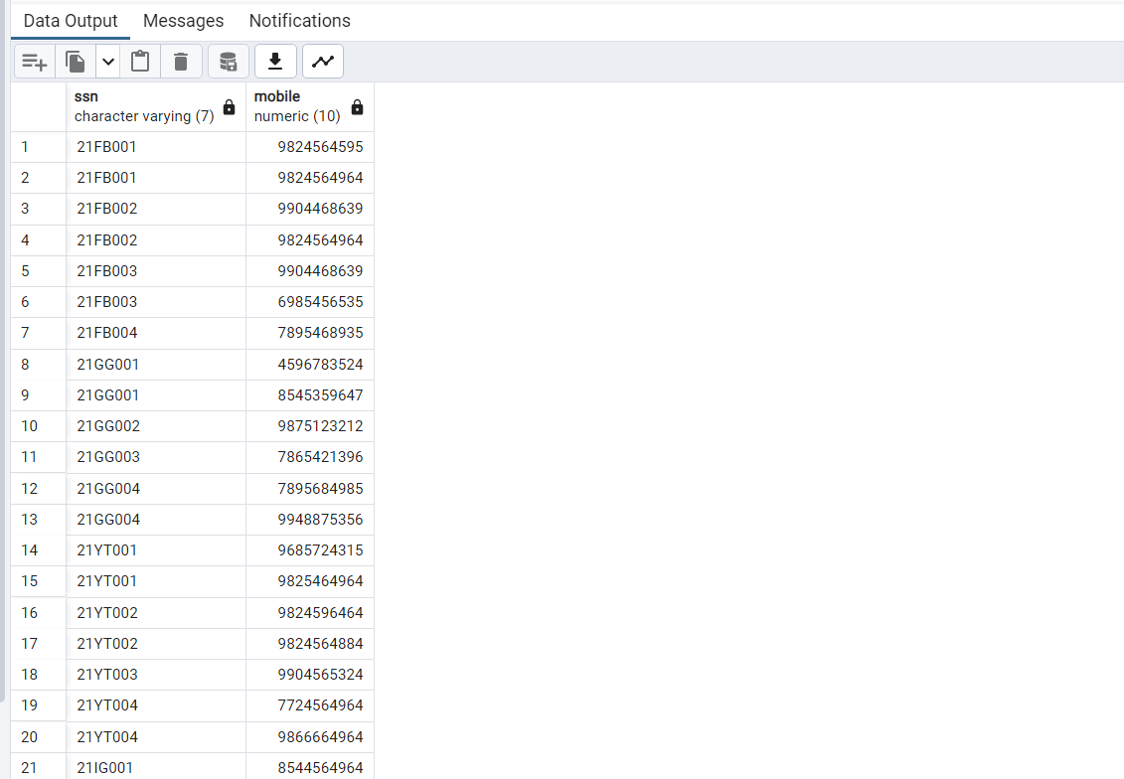

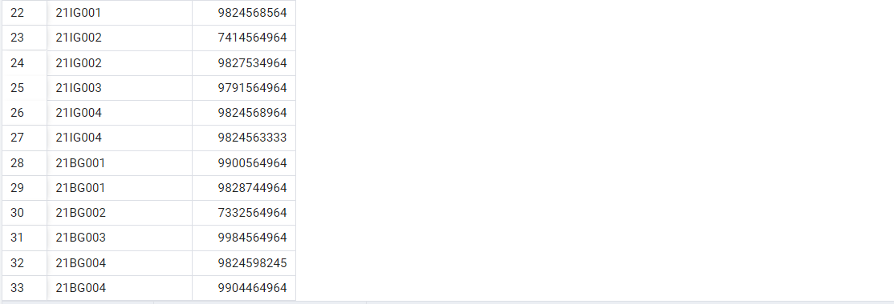

**3) Salary**

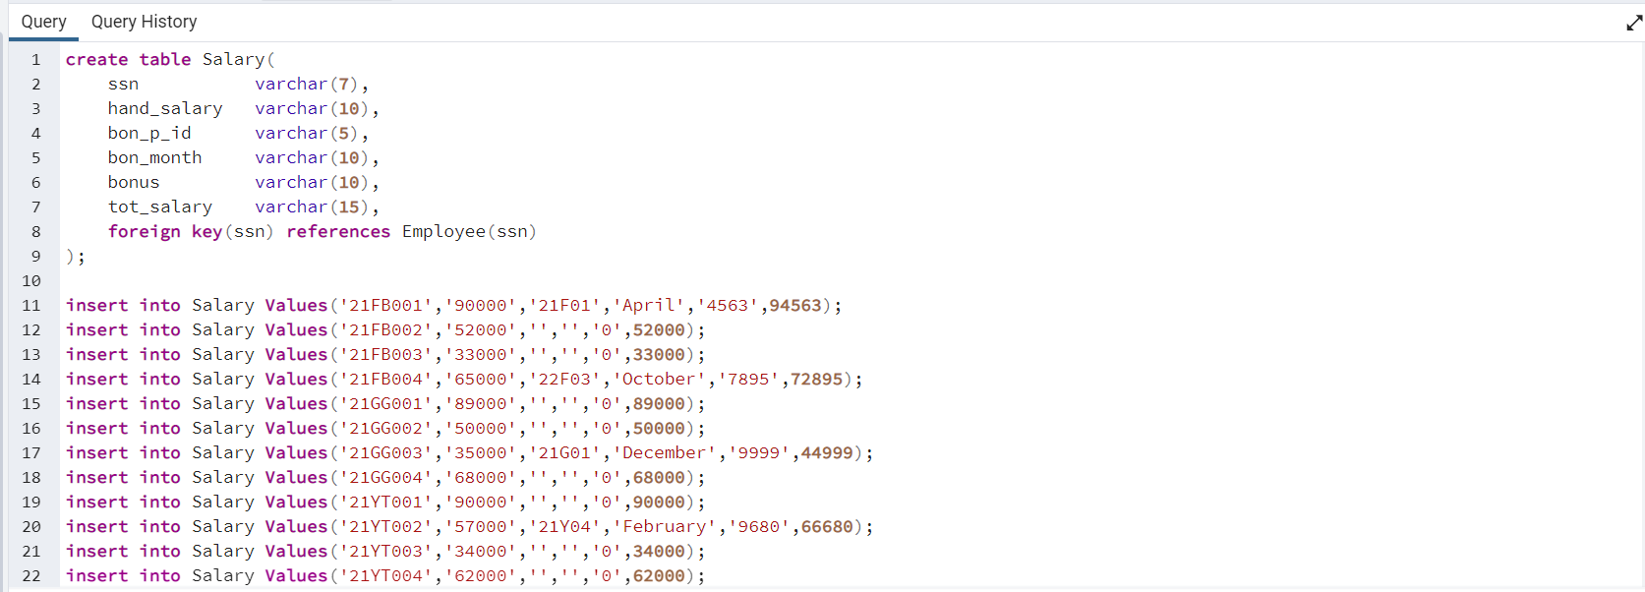

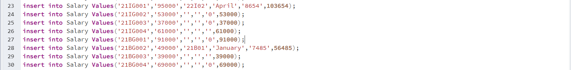

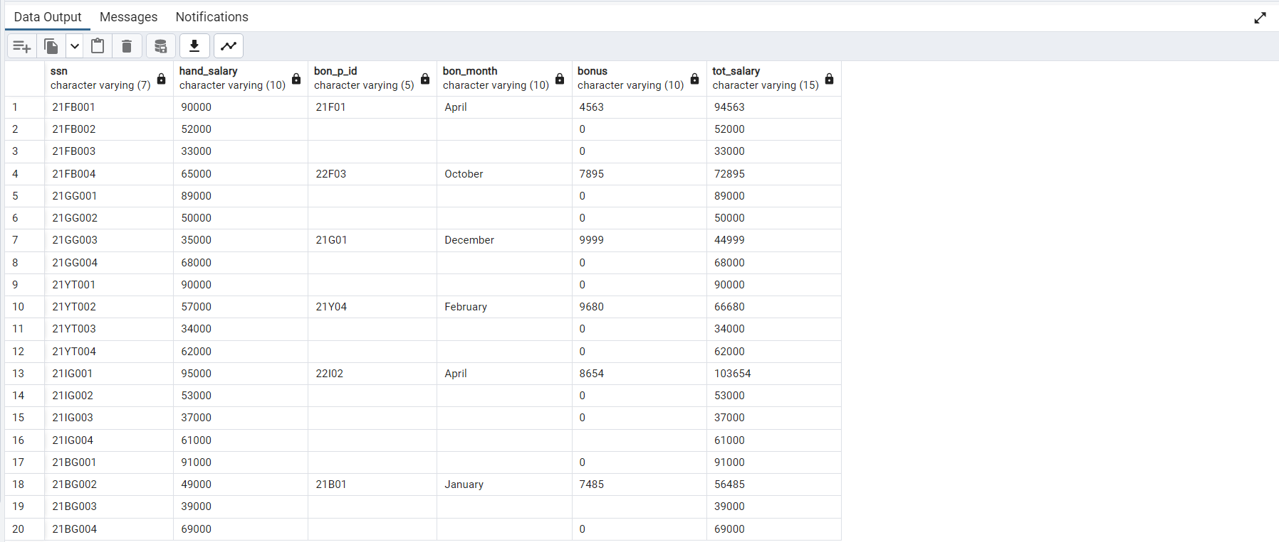

**4) Client**

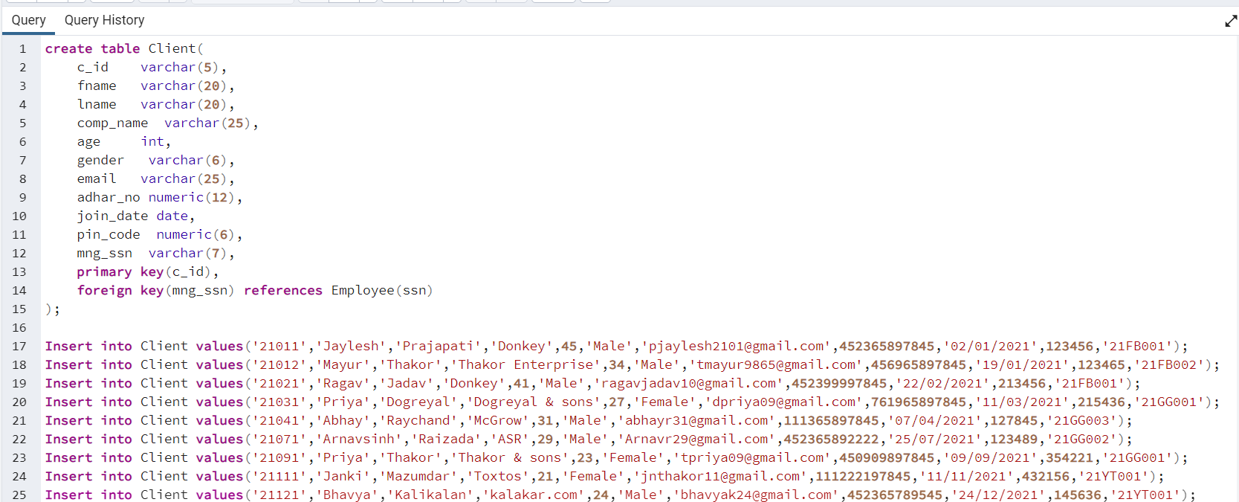

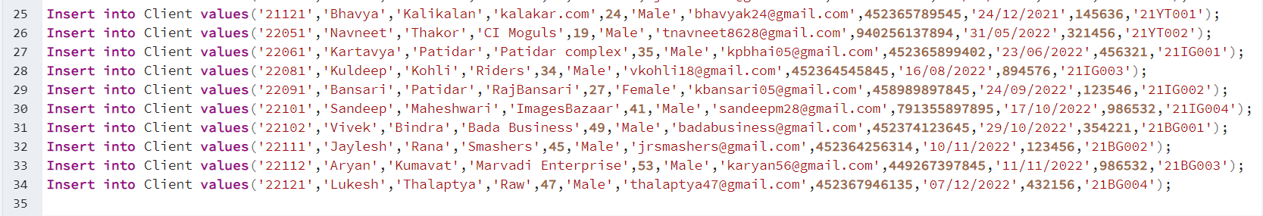

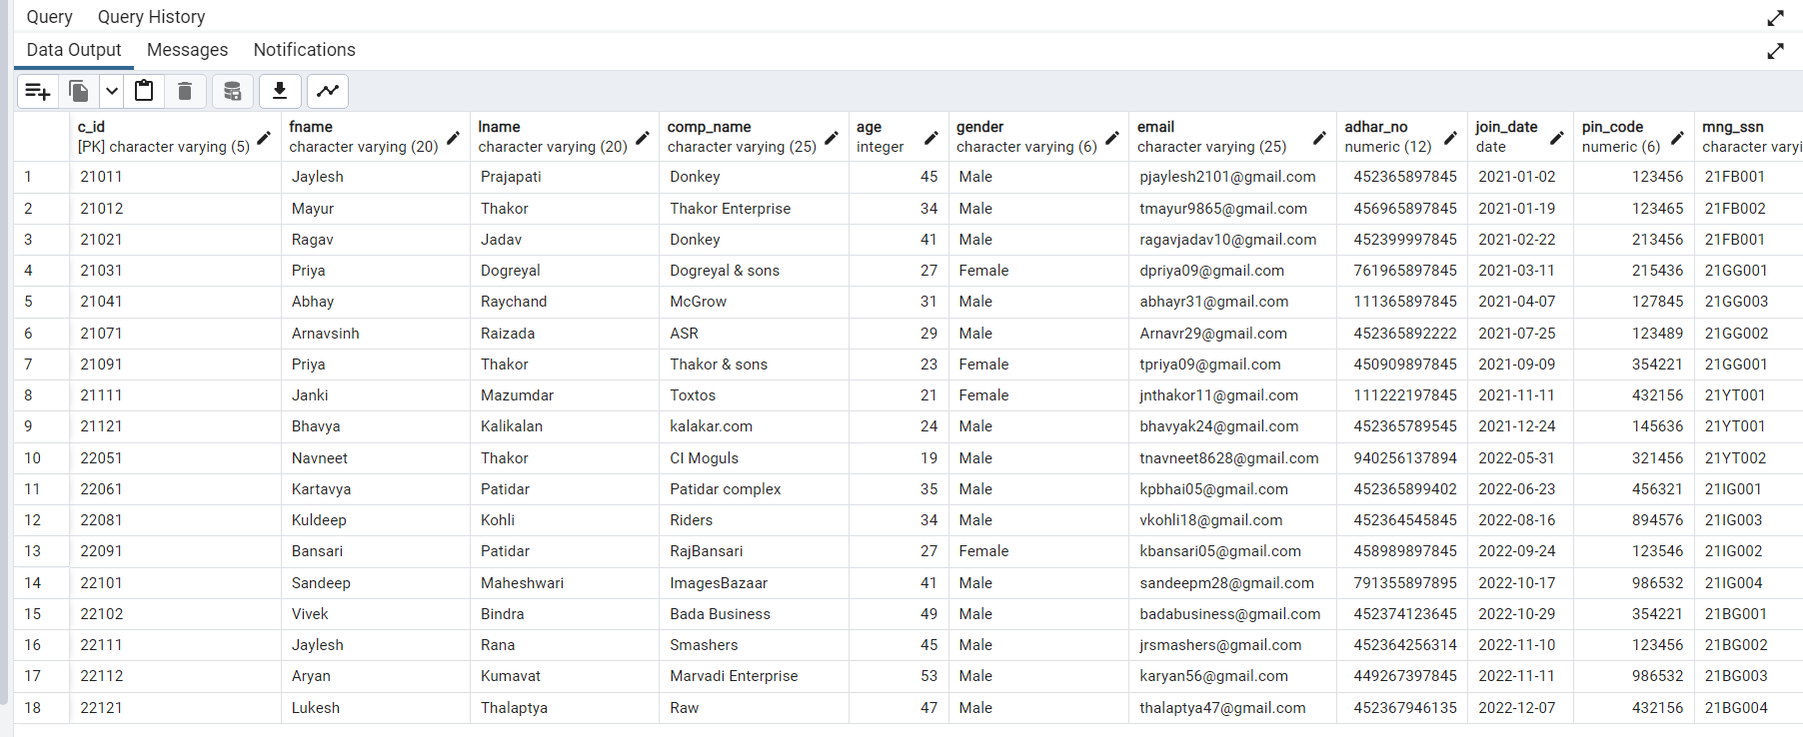

**5) Client_Mobile**

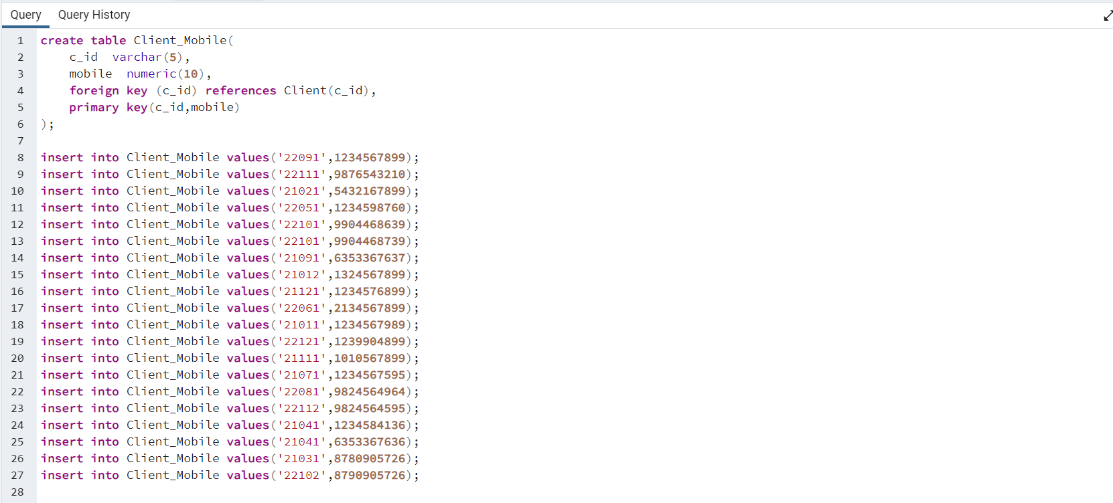

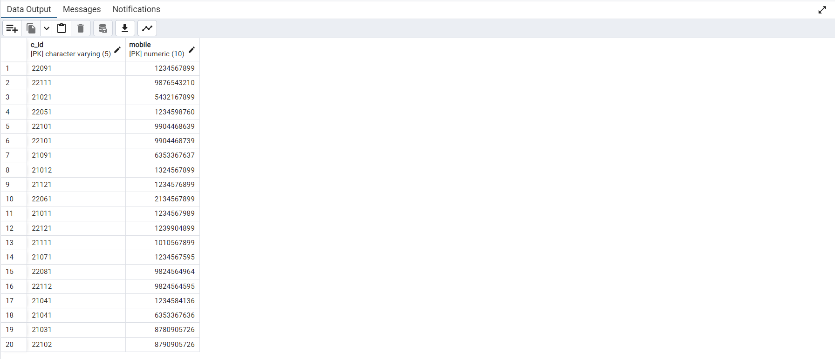

**6) Client_acc**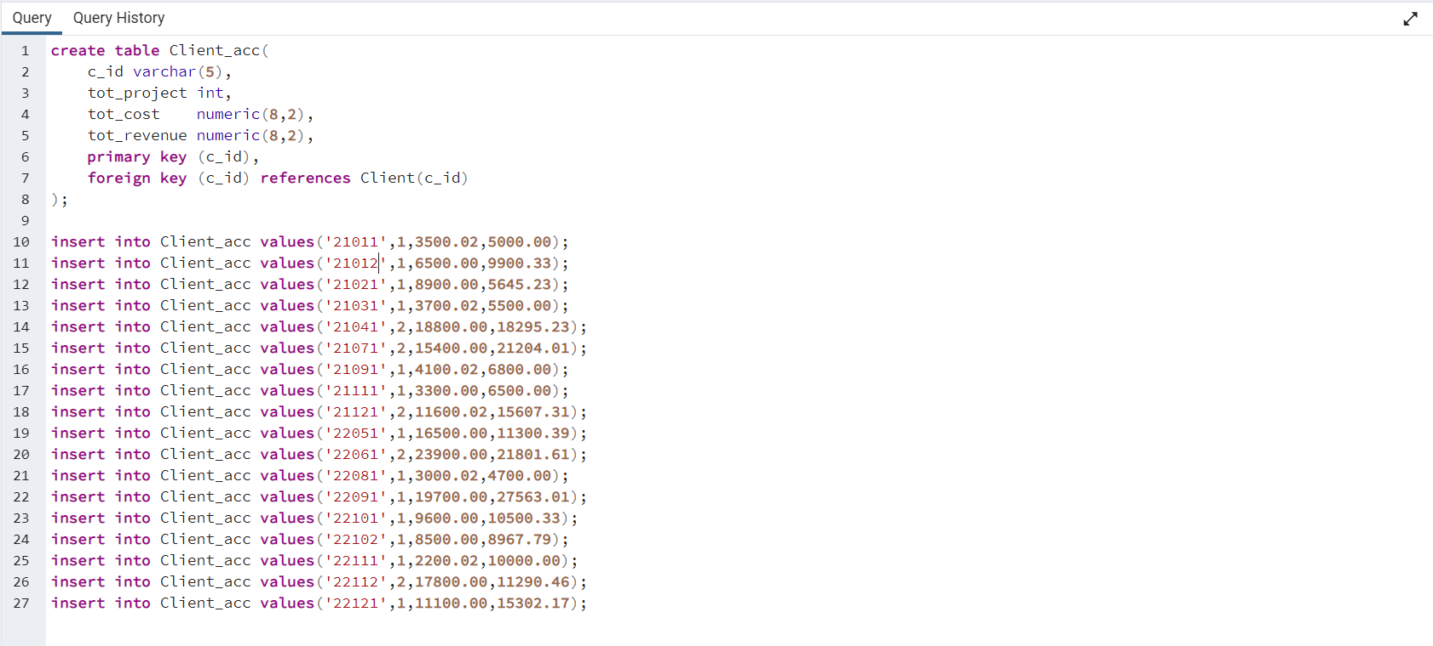

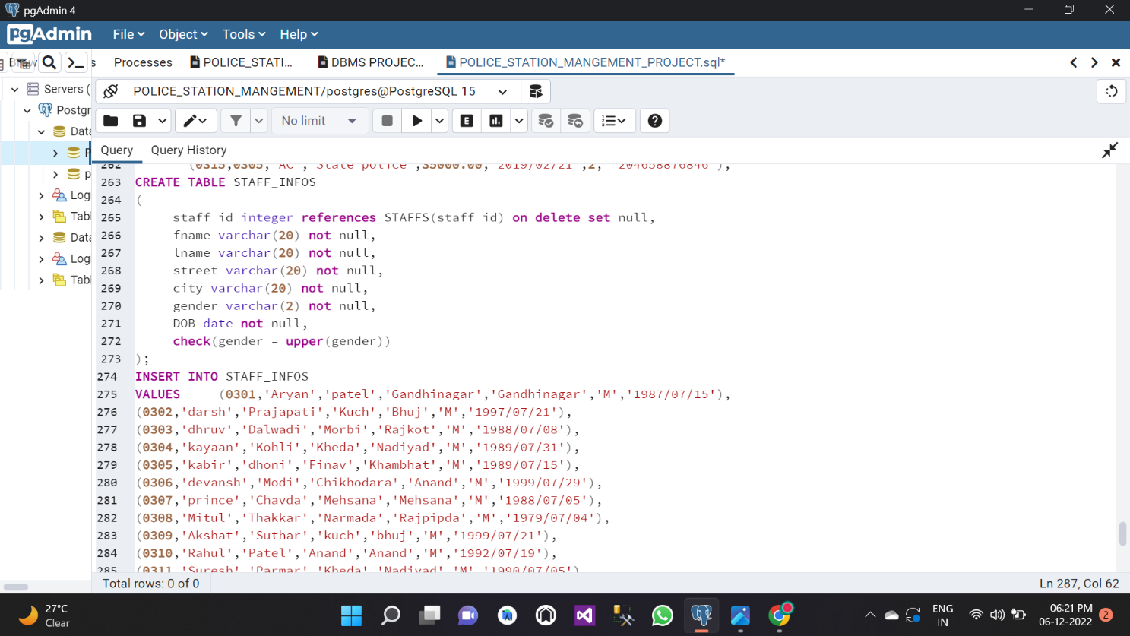

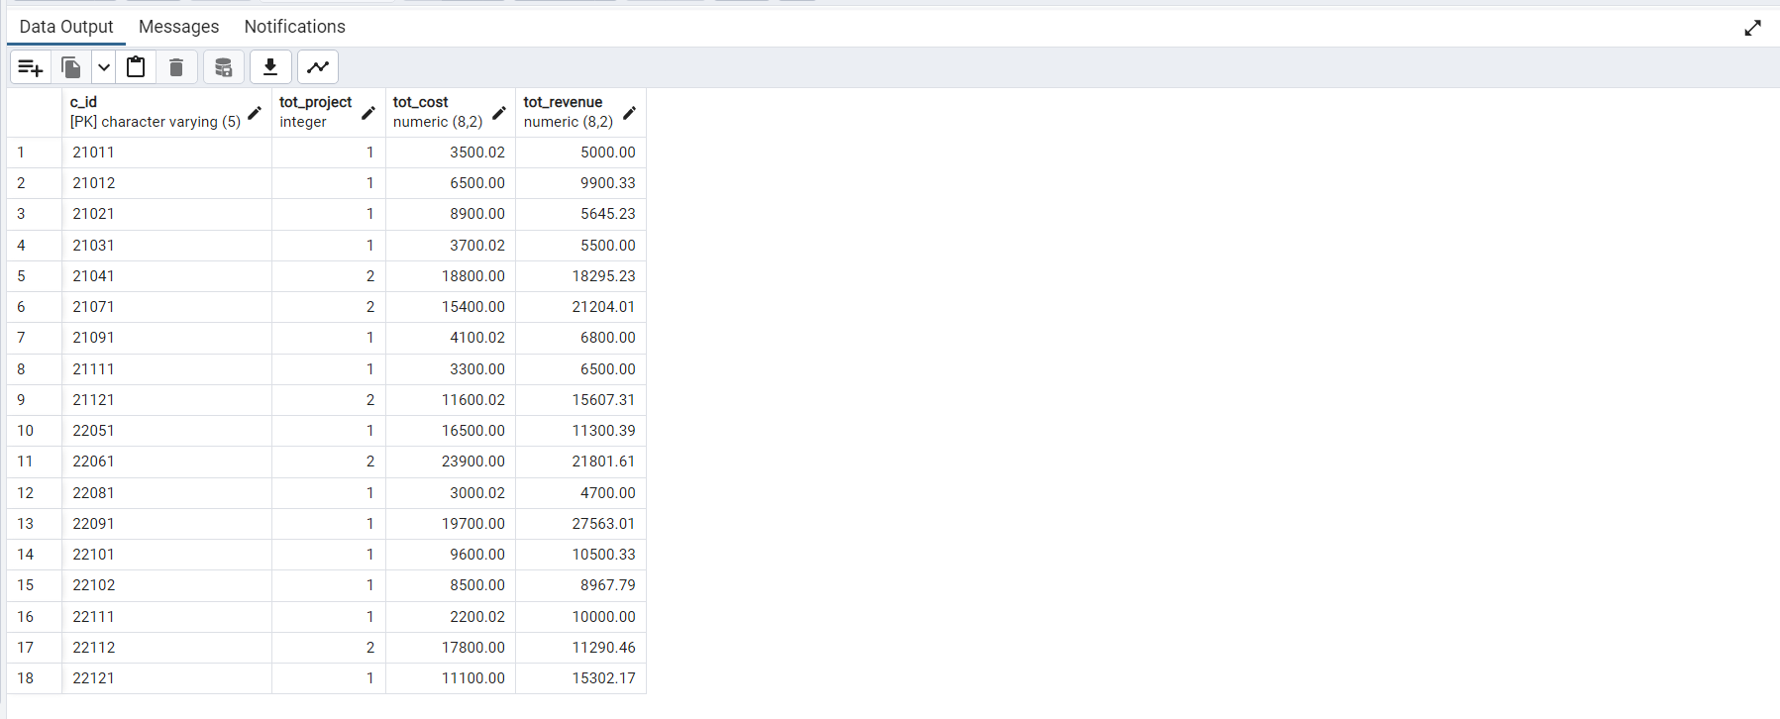

**8) Department**

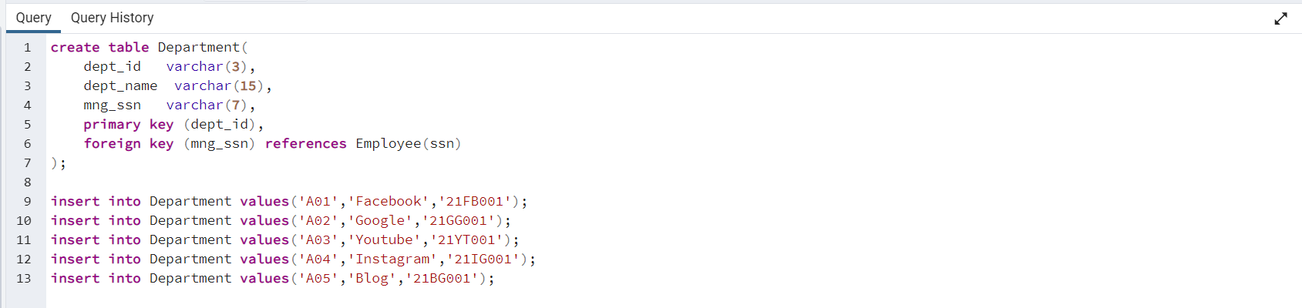

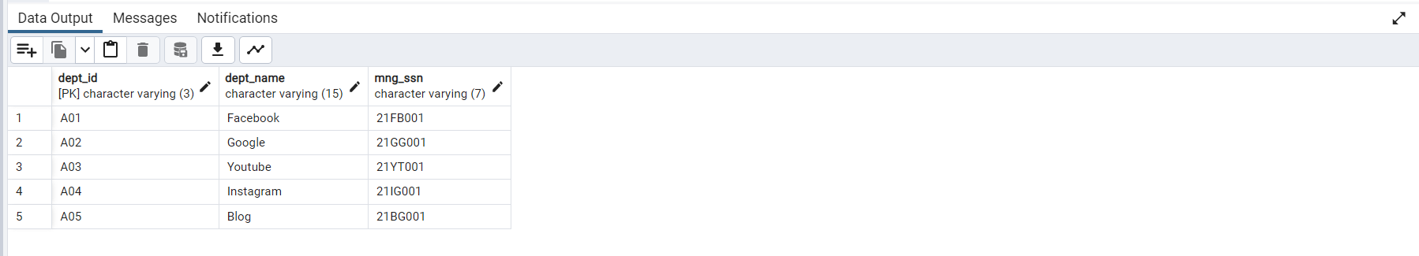

**9) Emp_Proj**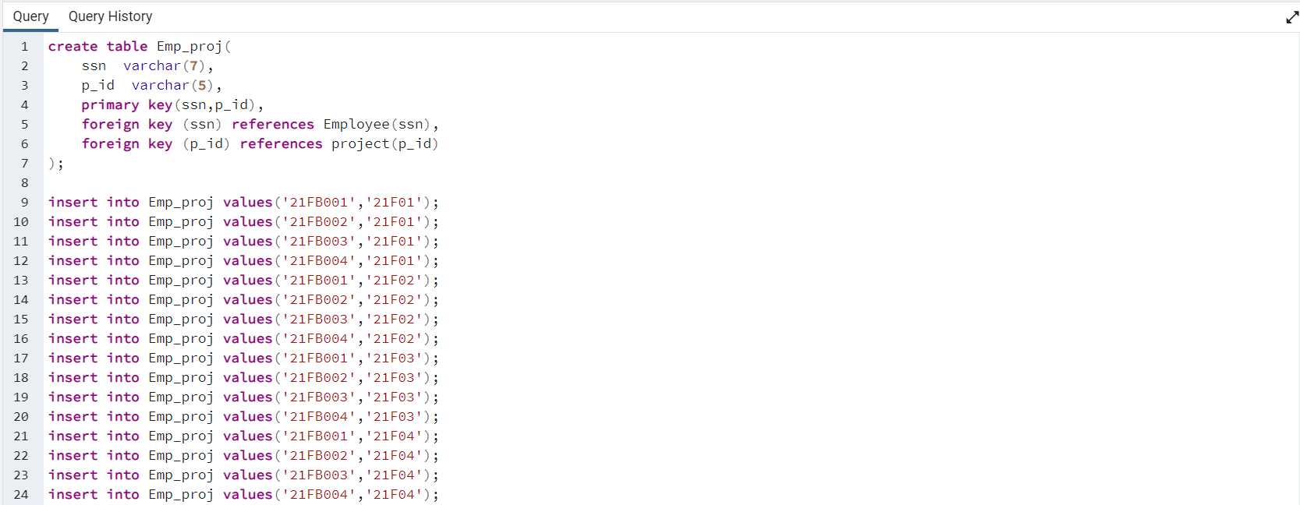

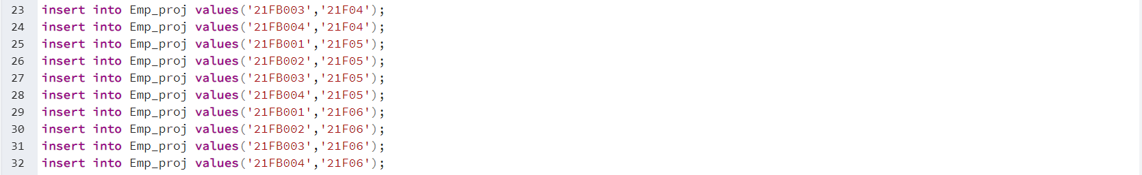

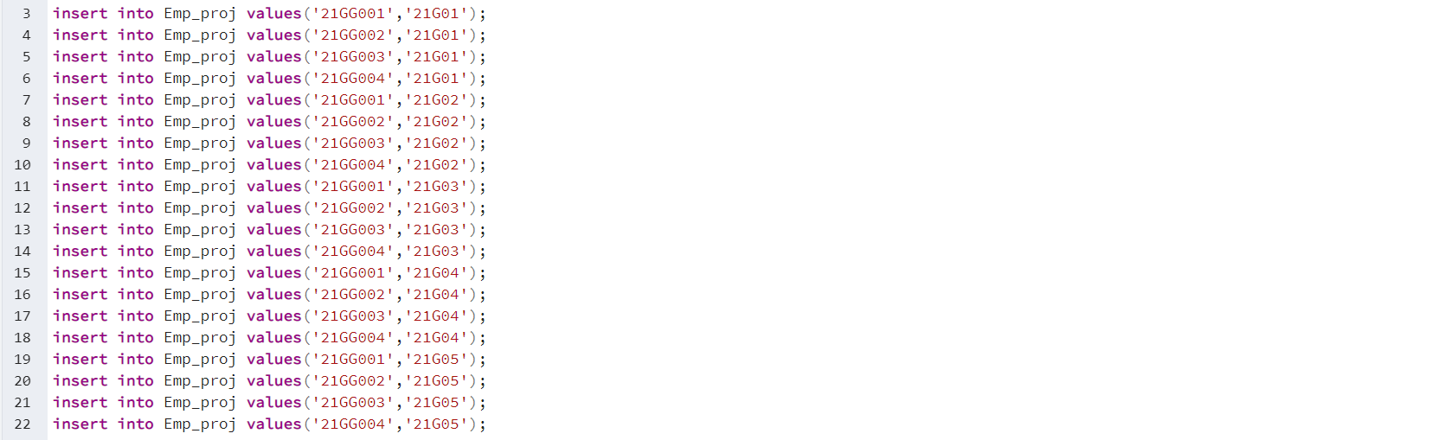

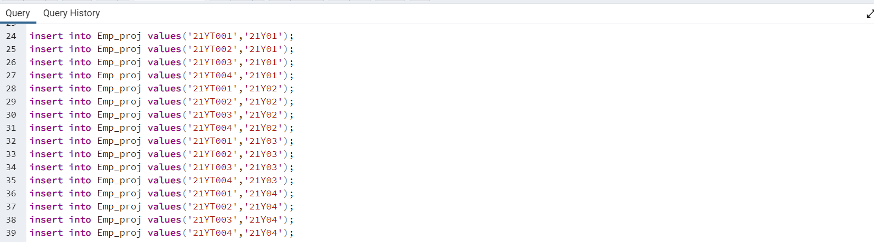

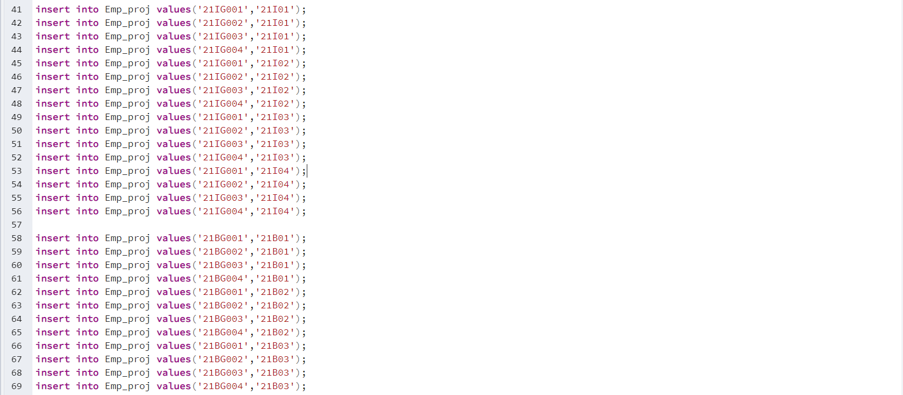

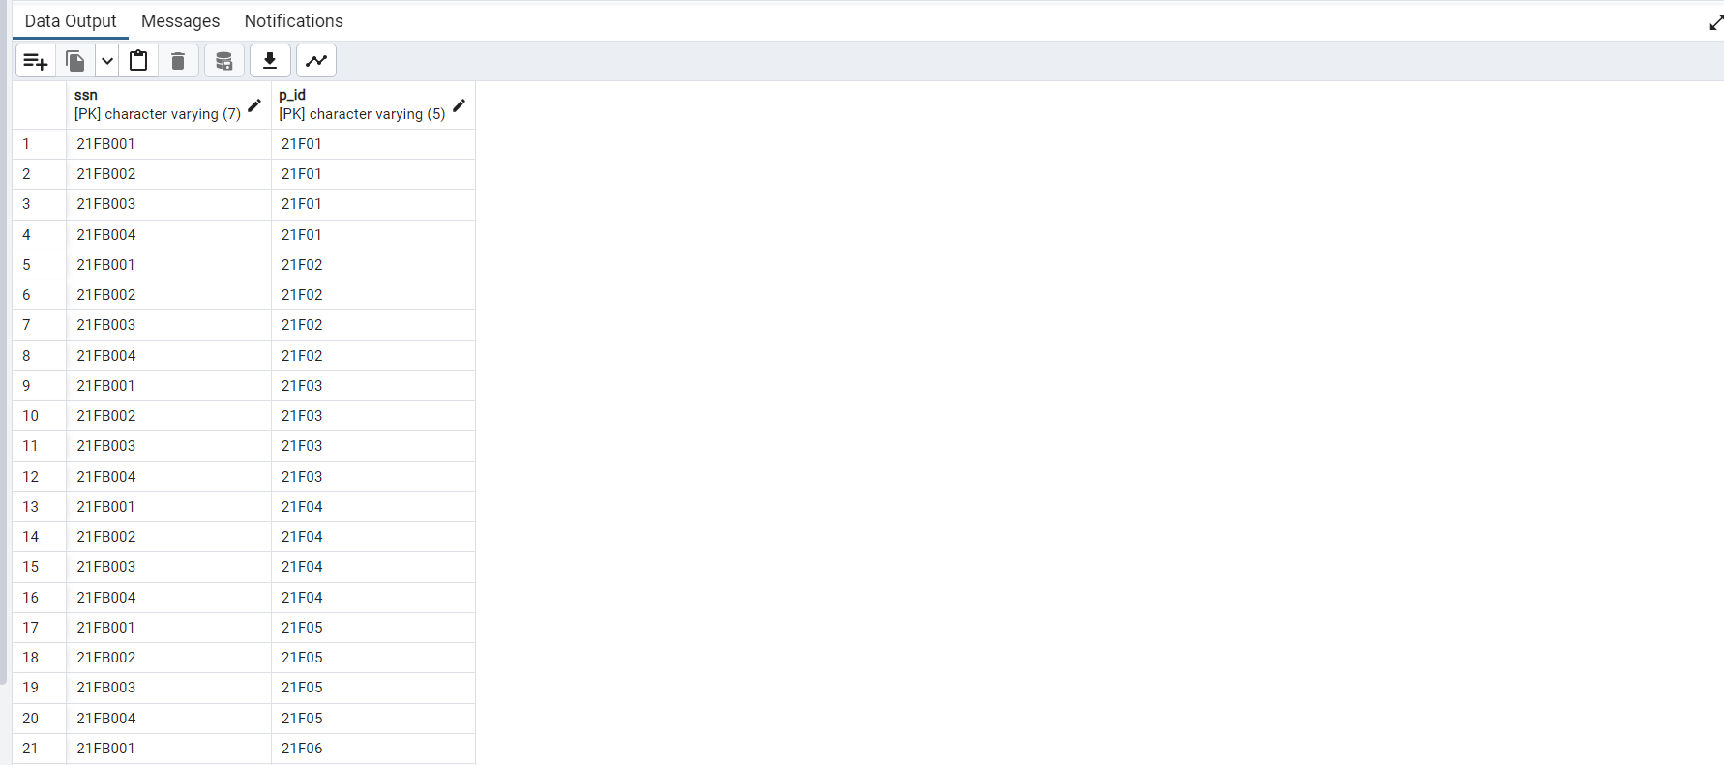

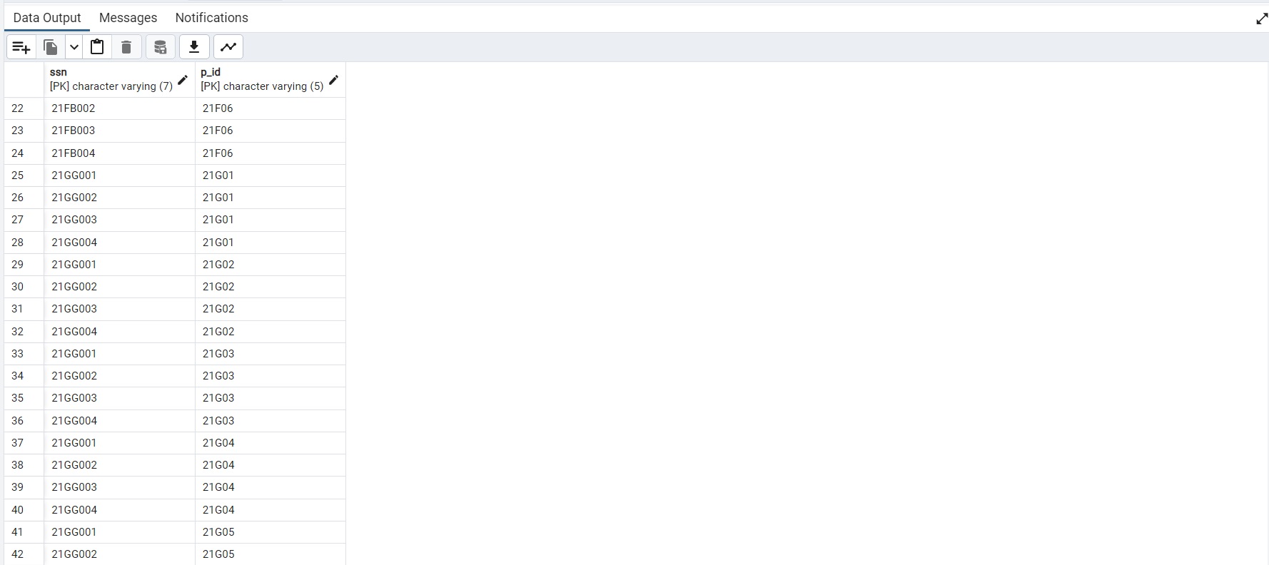

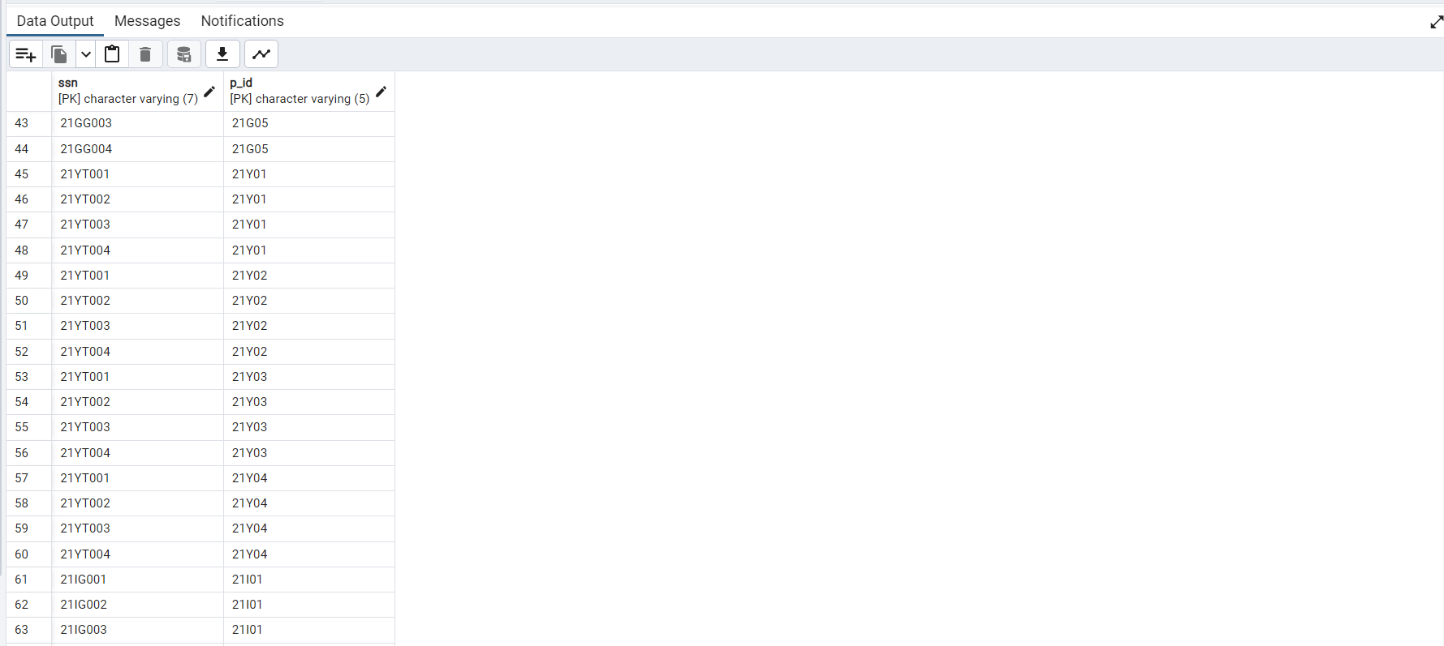

**10)EC_pin**

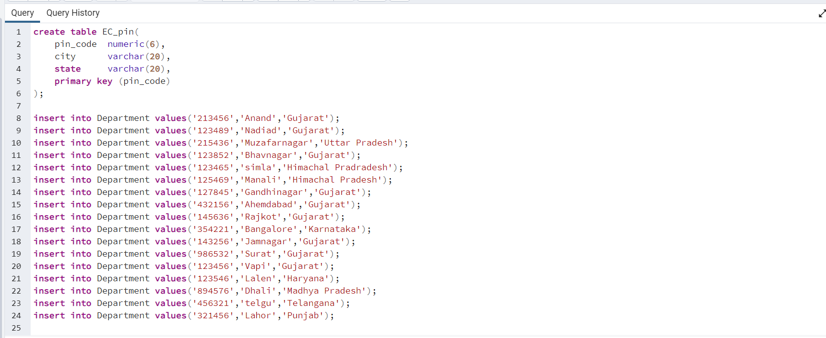

**Some queries with output to retrieve vital records from the database.**

**Find out how many Clients has more than one projects.**

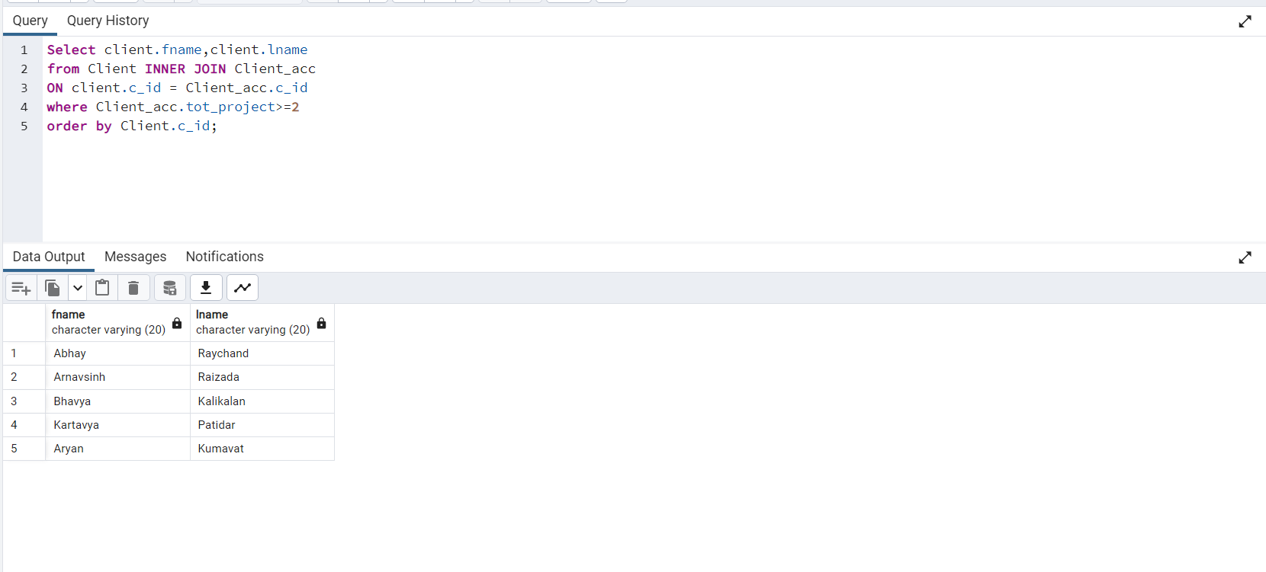

**Display the detail about employees (ssn, fname, lname) who got bonus in April month**

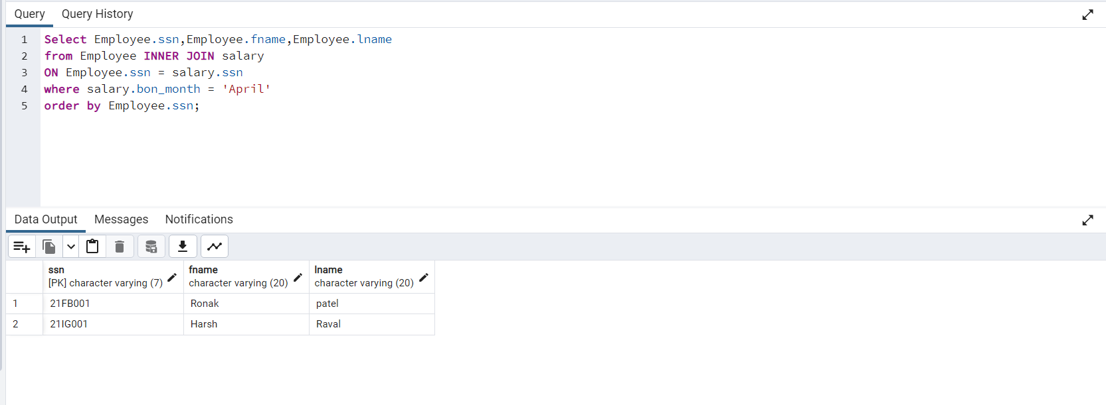

**List out the name of the department whose manager’s first name consists letter ‘r’ in it.**

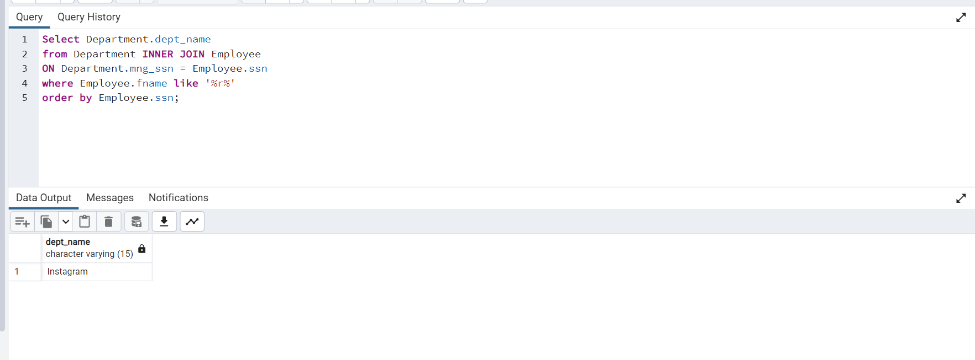

**Found out the most the name of clients who are facing loss on there investment, also find out name of his/her manager.**

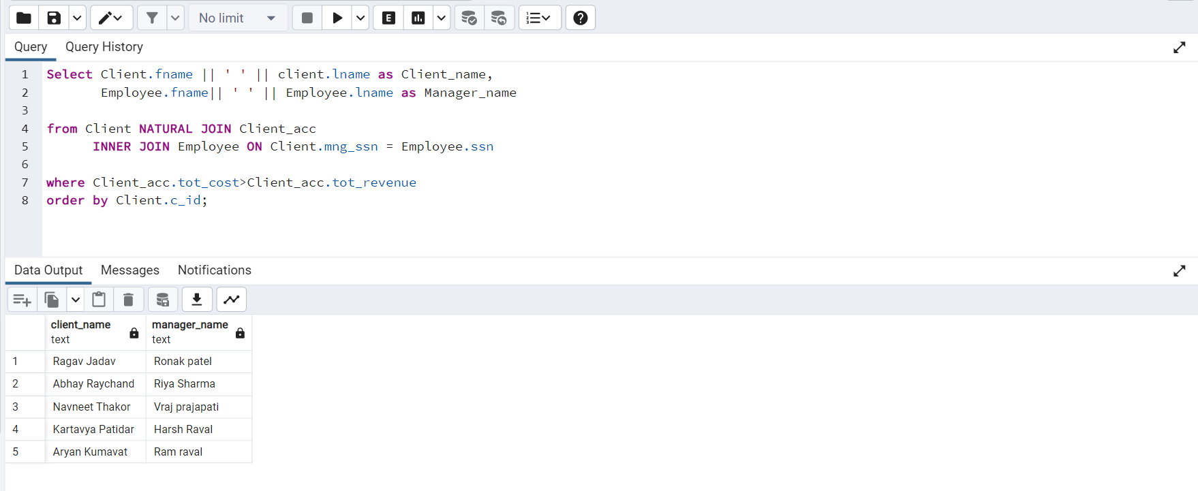

**Found out Employees who haven’t got any bonus.**

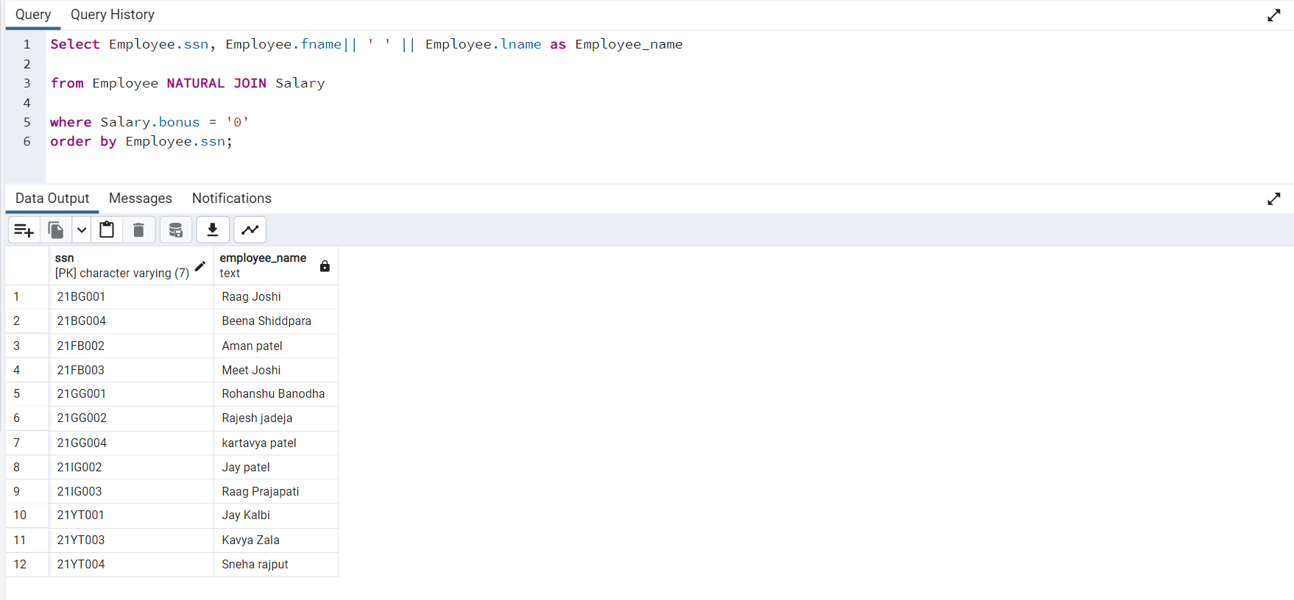

**Find out Department name who has more than 3 projects.**

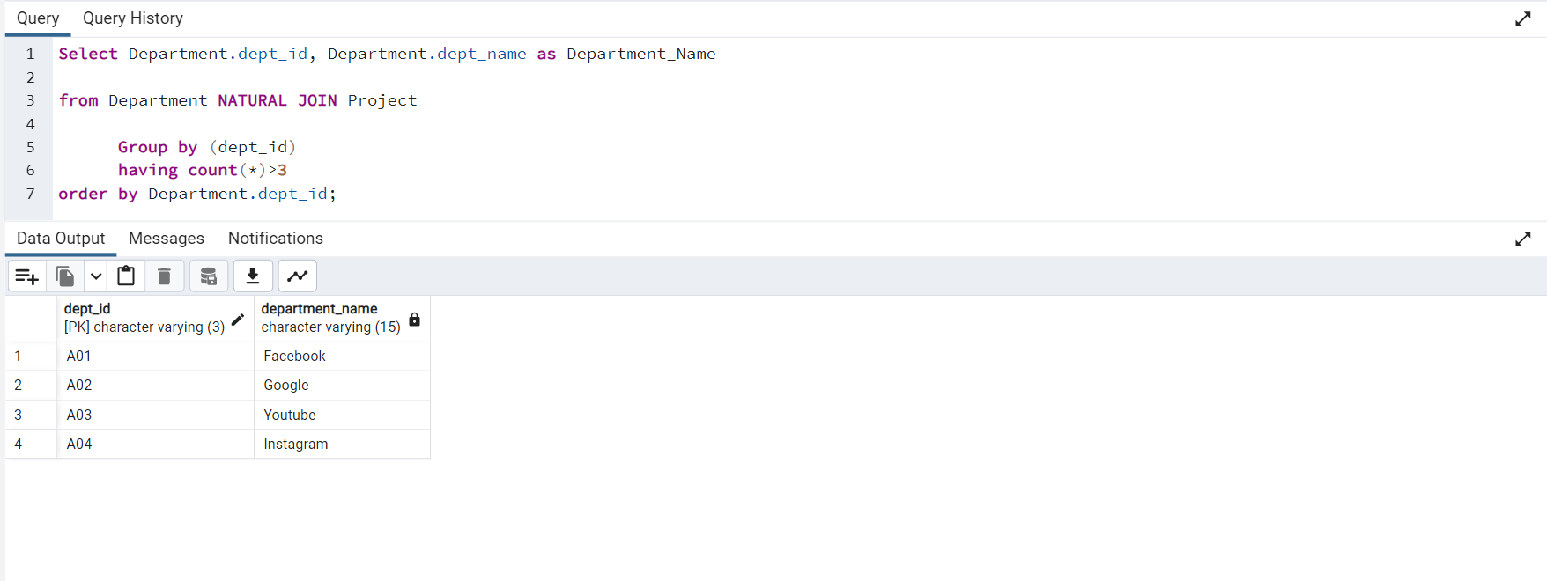

**Found out the name of Clients who has multiple active projects or invested more than 25000 rupees in it.**

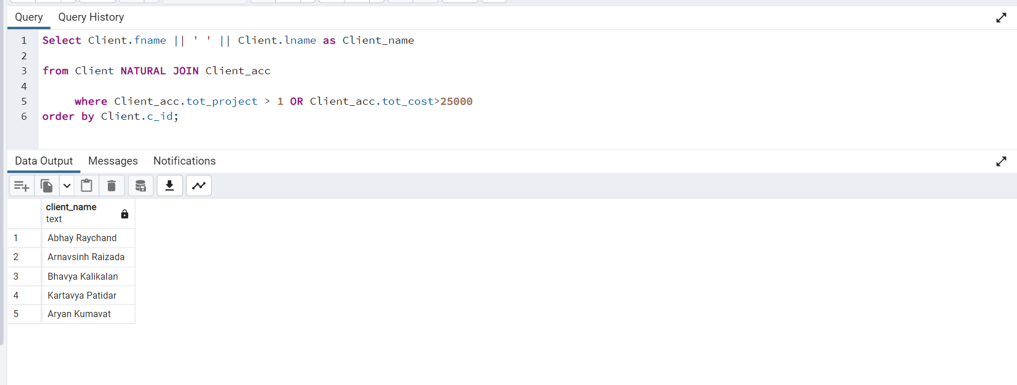

**Find out all the name of all the managers along with there Department name who are also managing some clients**

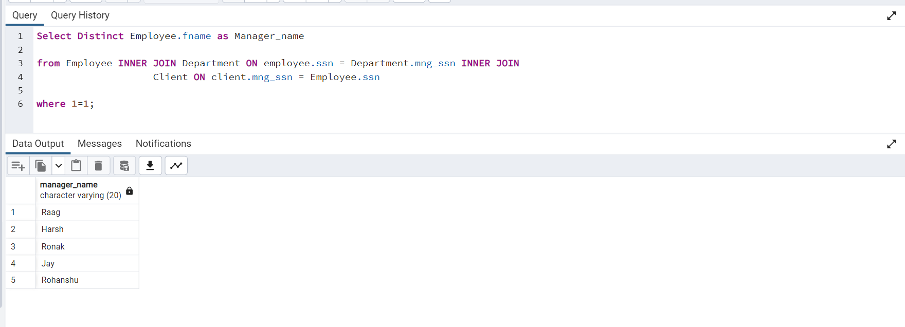

**Found out Employees who have two mobile numbers.**

